Delays by airlines

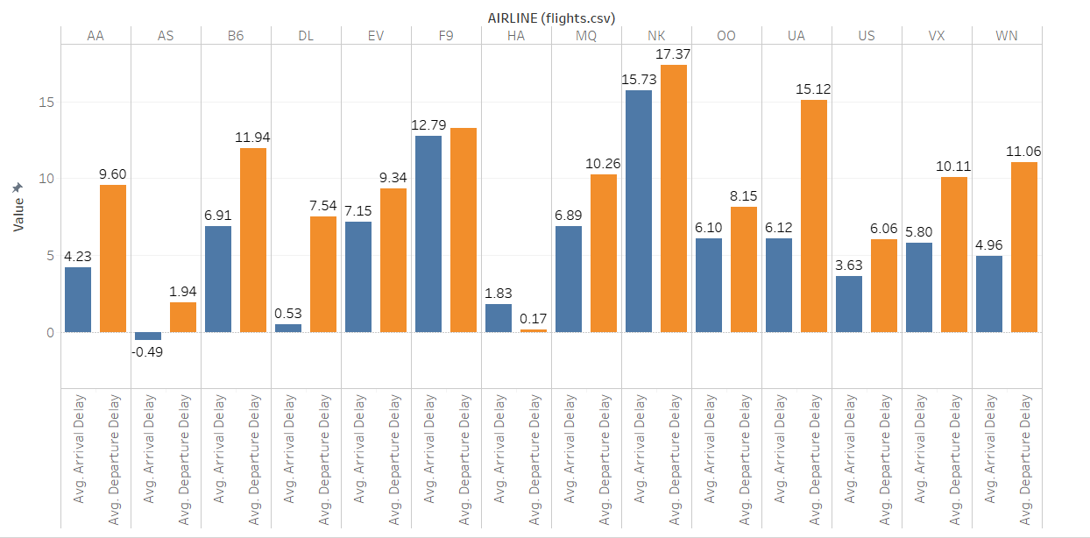

This chart shows the average arrival and departure delay times for each airline found in the dataset. Most airlines have higher departure delay times than arrival times, there is only one airline where the arrival time is higher than the departure time, which is HA. Airlines such as AA, UA and WN have departure delay times double their arrival delay times, while others are much closer in contrast. There is only one airline where there is negative arrival delay time, which means the planes arrives early, which is AS.

I chose the bar chart because it able to create an easy visual for showing the difference between the two delay times, and the difference between the airlines as they are neatly defined as categories.

Delays by month, day of week

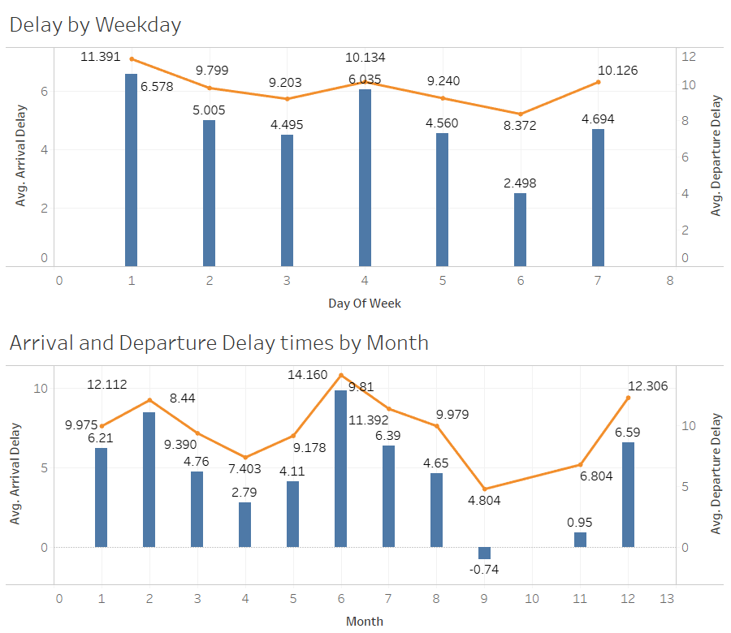

The trends of average arrival Delay and average departure Delay by Weekday. The orange line represents departure delay times, while the blue bars represent arrival delay times. Monday and Thursday had the highest arrival and departure delay times when compared to the other days of the week. Also, they had the smallest difference between their arrival and departure delay times. Saturday has the lowest arrival and departure delay times when compared to the other days of the week, and also it has the smallest difference between its arrival and departure delay times.

The trends of average arrival Delay and average departure Delay by Month. The orange line represents departure delay times, while the blue bars represent arrival delay times. The months of February, and June are when both delay times are very similar as they are both higher than the other months and have a smaller difference in arrival and departure delay times. However, for the month September, where is actually negative arrival delay times, which means the planes were early. Also, the month of October has a arrival delay time of 0, which means that there is either no data on it, or all planes were exactly on time.

I choose the line chart in combination with the bar chart as it separates the two measures cleanly and is able to show the trends of arrival and departure delays throughout the months of the year.

Delays correlation with distance

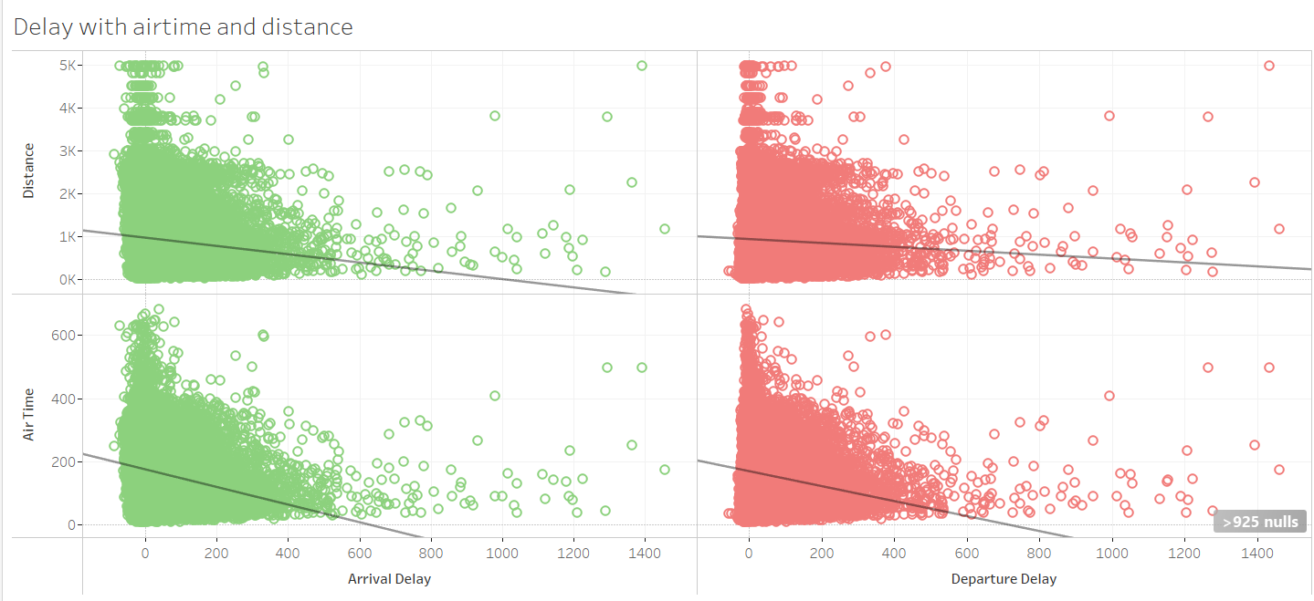

In the upper left quadrant, the correlation between distance and arrival delay has a R-squared value of 0.0084053, which means that it “indicates no or a weak relationship” (kb.tableau.com, 2017) between the two variables.

In the upper right quadrant, the correlation between distance and departure delay has a R-squared value of 0.0020506, which means that it “indicates no or a weak relationship” (kb.tableau.com, 2017) between the two variables.

In the bottom left quadrant, the correlation between air time and arrival delay has a R-squared value of 0.0522852, which means that it “indicates no or a weak relationship” (kb.tableau.com, 2017) between the two variables.

In the bottom right quadrant, the correlation between air time and departure delay has a R-squared value of 0.0388591, which means that it “indicates no or a weak relationship” (kb.tableau.com, 2017) between the two variables.

Overall, there is no indication that distance and airtime has any affect on delays of a flight. I chose the scatter plot chart with the trend lines because it is able to visually show the correlation of airtime and distance have with arrival and departure delay times.

References:

Finding the Pearson correlation | Tableau software. (2017, February 15). Retrieved from https://kb.tableau.com/articles/howto/finding-the-pearson-correlation

I was not able to provide links to the tableau public because I there is a lack of the option in my tableau software and there is an error every time I tried logging into tableau online to publish my findings, so I have provided the screen shots of all the filters as requested.

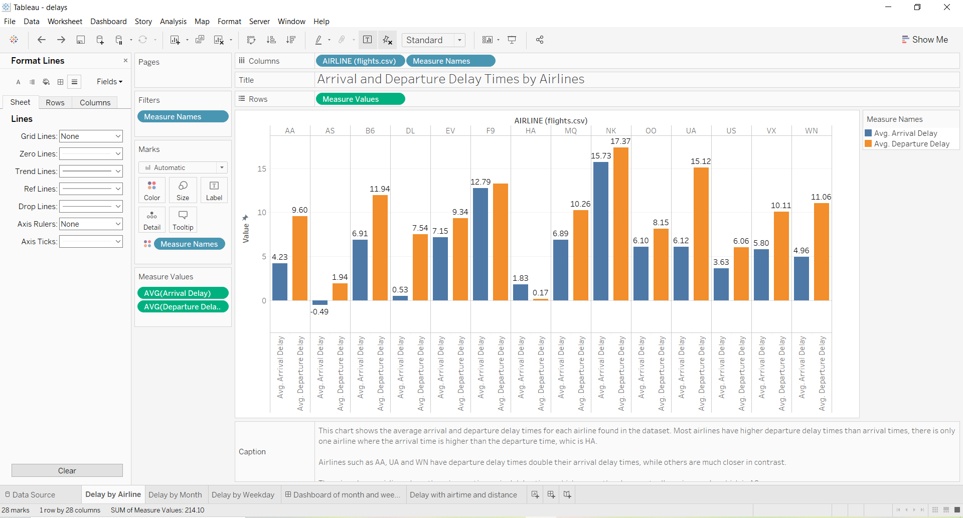

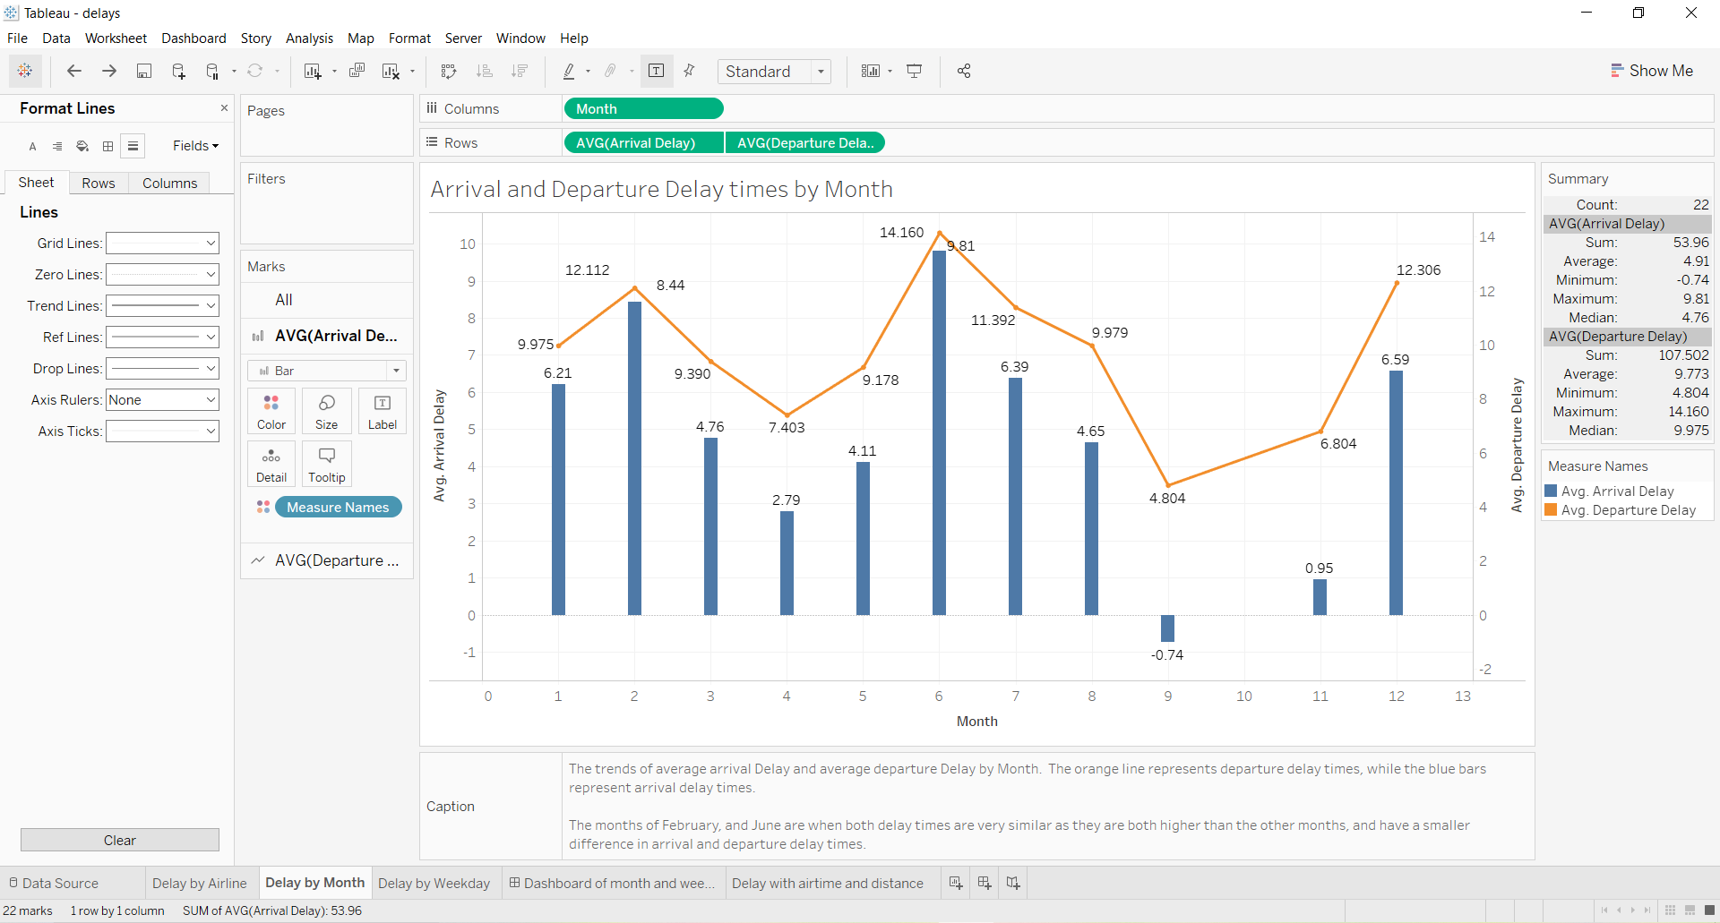

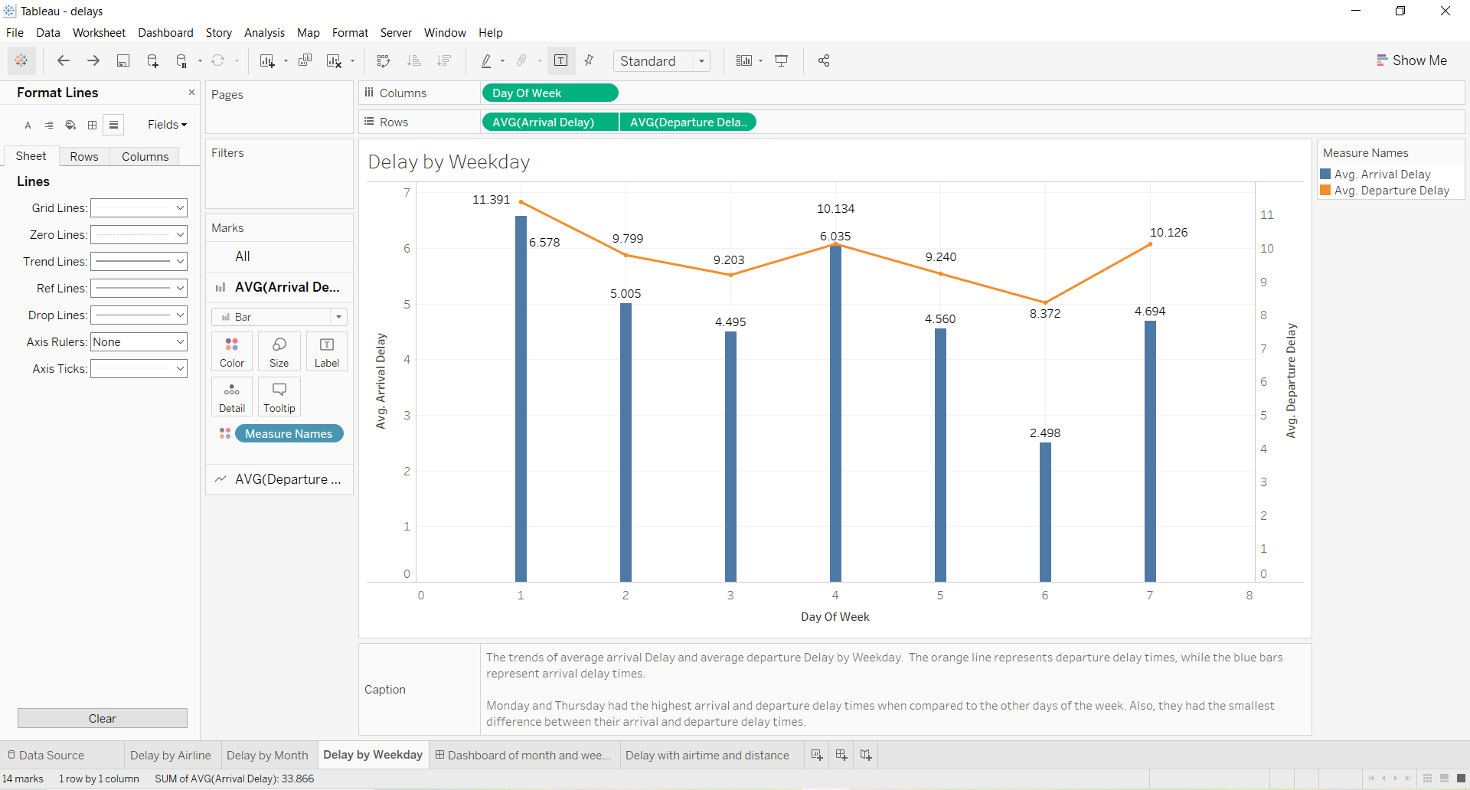

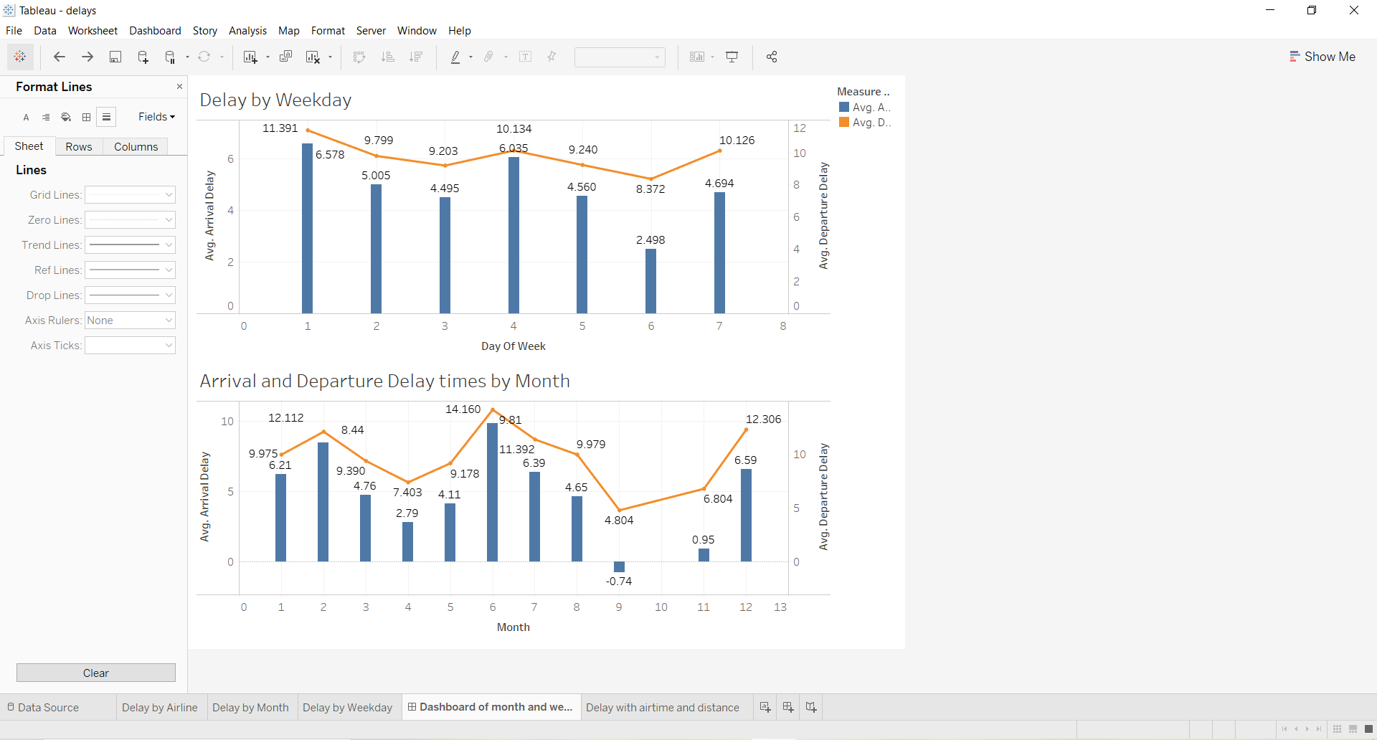

Color blind friendly colors used for this chart

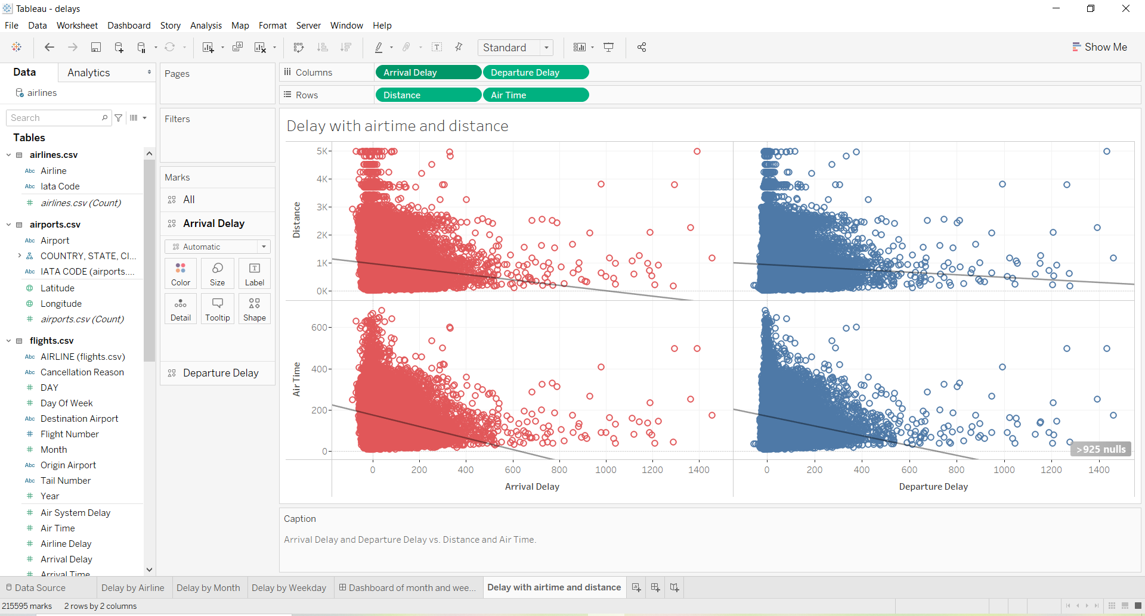

Added filter for months from 1 to 12 for delays by airlines sheet:

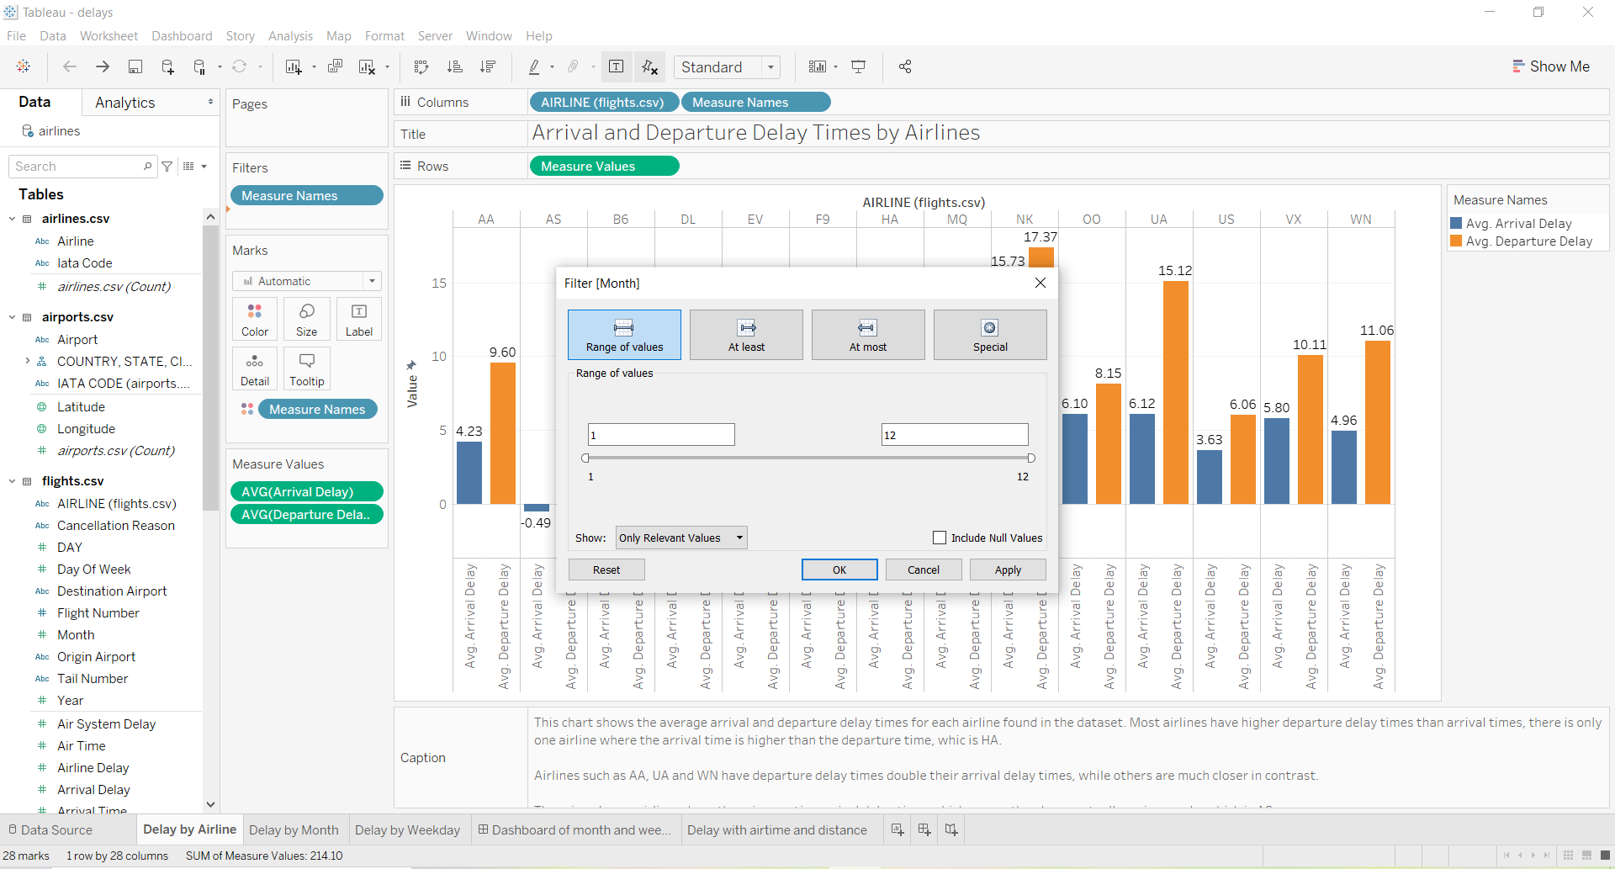

Added filter for months 2 only for delays by airlines sheet:

